**Comsats University, Islamabad, Attock Campus**

**Department of Computer Science**

**Assignment: 04**

**Subject: Mobile Application Development**

**Program: BSSE-6**



**Submitted To: Mr. Muhammad Kamran**

**Submitted By:**

**Adeel Farooq**

**Registration Number:**

**SP22-BSE-030**

# **App.js:**

## **Code:**

import React from 'react';

import { NavigationContainer } from '@react-navigation/native';

import { createBottomTabNavigator } from '@react-navigation/bottom-tabs';

import HomeScreen from './HomeScreen';

import SensorScreen from './SensorScreen';

import { ApiProvider } from './ApiContext';

const Tab = createBottomTabNavigator();

export default function App() {

  return (

    <ApiProvider>

      <NavigationContainer>

        <Tab.Navigator>

          <Tab.Screen name="API" component={HomeScreen} />

          <Tab.Screen name="Sensor" component={SensorScreen} />

        </Tab.Navigator>

      </NavigationContainer>

    </ApiProvider>

  );

}

**HomeScreen.js:**

**Code:**

import React, { useContext } from 'react';

import { View, Button, Text } from 'react-native';

import { ApiContext } from './ApiContext';

const HomeScreen = () => {

  const { apiData, setApiData } = useContext(ApiContext);

  const getData = async () => {

    const res = await fetch('https://jsonplaceholder.typicode.com/posts/1');

    setApiData(await res.json());

  };

  const postData = async () => {

    const res = await fetch('https://jsonplaceholder.typicode.com/posts', {

      method: 'POST',

      body: JSON.stringify({ title: 'New Post', body: 'Content' }),

      headers: { 'Content-type': 'application/json; charset=UTF-8' },

    });

    setApiData(await res.json());

  };

  const putData = async () => {

    const res = await fetch('https://jsonplaceholder.typicode.com/posts/1', {

      method: 'PUT',

      body: JSON.stringify({ title: 'Updated Post', body: 'Updated content' }),

      headers: { 'Content-type': 'application/json; charset=UTF-8' },

    });

    setApiData(await res.json());

  };

  return (

    <View>

      <Button title="GET" onPress={getData} />

      <Button title="POST" onPress={postData} />

      <Button title="PUT" onPress={putData} />

      <Text>{apiData ? JSON.stringify(apiData, null, 2) : 'No data yet'}</Text>

    </View>

  );

};

export default HomeScreen;

**SensorScreen.js:**

**Code:**

import React, { useEffect, useState } from 'react';

import { View, Text, StyleSheet } from 'react-native';

import { Accelerometer } from 'expo-sensors';

const SensorScreen = () => {

  const [data, setData] = useState({ x: 0, y: 0, z: 0 });

  const [subscription, setSubscription] = useState(null);

  const _subscribe = () => {

    const sub = Accelerometer.addListener(accelerometerData => {

      setData(accelerometerData);

    });

    setSubscription(sub);

  };

  const _unsubscribe = () => {

    subscription && subscription.remove();

    setSubscription(null);

  };

  useEffect(() => {

    _subscribe();

    return () => _unsubscribe();

  }, []);

  return (

    <View style={styles.container}>

      <Text style={styles.header}>Accelerometer Data</Text>

      <Text style={styles.value}>X: {data.x.toFixed(2)}</Text>

      <Text style={styles.value}>Y: {data.y.toFixed(2)}</Text>

      <Text style={styles.value}>Z: {data.z.toFixed(2)}</Text>

    </View>

  );

};

const styles = StyleSheet.create({

  container: {

    flex: 1,

    paddingTop: 60,

    alignItems: 'center',

    backgroundColor: '#f0f8ff',

  },

  header: {

    fontSize: 22,

    marginBottom: 20,

    fontWeight: 'bold',

  },

  value: {

    fontSize: 18,

    marginVertical: 5,

  },

});

export default SensorScreen;

**APIContext.js**

**Code:**

import React, { createContext, useState } from 'react';

export const ApiContext = createContext();

export const ApiProvider = ({ children }) => {

  const [apiData, setApiData] = useState(null);

  return (

    <ApiContext.Provider value={{ apiData, setApiData }}>

      {children}

    </ApiContext.Provider>

  );

};

**Output:**

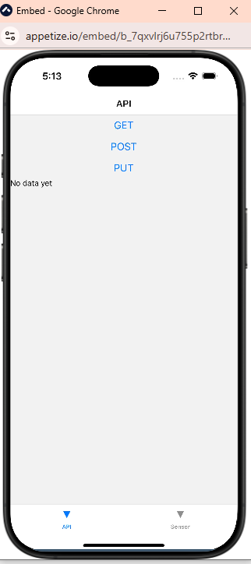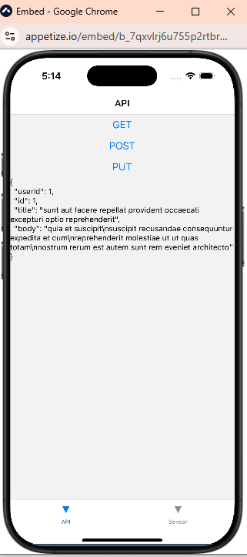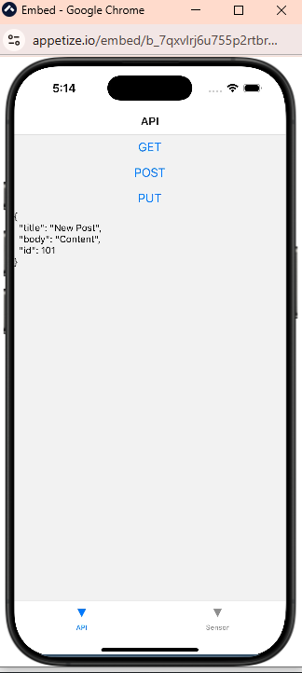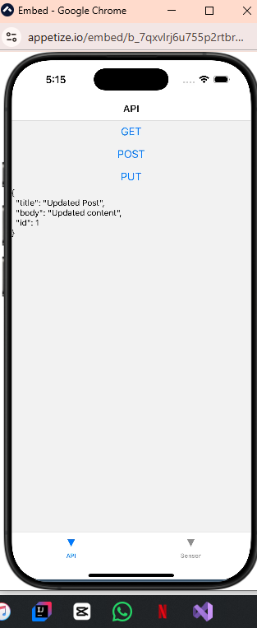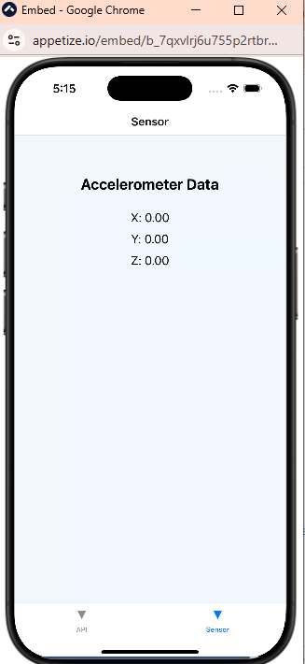

**URL Link:**

[**https://snack.expo.dev/@adeelkhattak01/apis**](https://snack.expo.dev/@adeelkhattak01/apis)